Vicki Swales

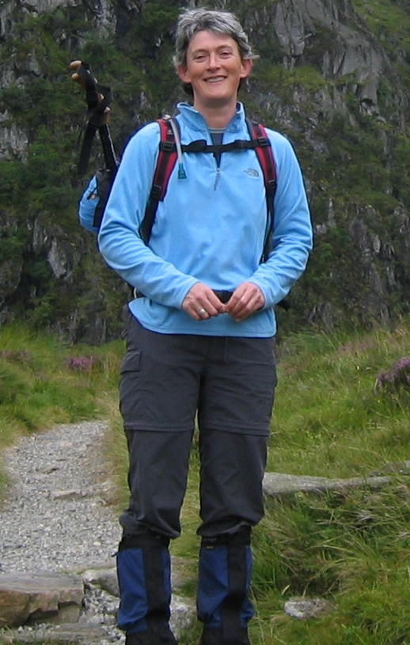

Vicki Swales is an independent consultant working on UK and EU rural and environmental issues. She is an Associate Senior Fellow of the Institute for European Environmental Policy (IEEP) and a non-executive Director of Assured Food Standards. Vicki has spent the past 18 years working on UK and EU agriculture and rural policy promoting the integration of the environment and the need for sustainable land use policies. She has worked on rural policy issues for a local authority in the south west of England and NGOs including the National Trust for Scotland and the RSPB. Before going freelance, she was Head of the Agriculture and Rural Development Programme at IEEP. Whilst there she led policy research contracts for the European Commission, Defra and SEERAD, amongst others. Vicki has a wide range of rural policy interests but a particular interest in the economic, social and environmental problems facing upland areas. In 2000/2001 she was a member of a Government Taskforce looking at the future of hill farming in England and has undertaken various research contracts in this field.

Vicki was brought up in the Forest of Bowland in rural Lancashire. She later attended the University of North Wales, Bangor and was awarded a B.SC. (Hons) in Agriculture in 1989 before going on to receive an M.Sc. in Natural Resource Management from the University of Edinburgh in 1991. Having spent 11 years working in the south-east of England, Vicki now lives in Edinburgh, where she frequently enjoys escaping the city to indulge her passions for hill walking and cycling.

